
Dashboard Design

Date | 28 October 2026
Team ID | To be filled by team
Project Name | Healthcare Risk Analysis — Optional Snowflake Dashboard Concept
Maximum Marks | 5 Marks

Activity 1: Interactive and visually appealing dashboards
Creating an effective Streamlit dashboard involves presenting business data stored in Snowflake through clear, interactive, and easy-to-understand visualizations. Students should design the dashboard so that users can quickly understand important KPIs, trends, comparisons, and business insights.
- Clear and Intuitive Layout
- Use Appropriate Visualizations
- Colour and Theming
- Interactive Filters and Slicers
- Drill-Down Capabilities
- Responsive Design
- Custom Visuals and Icons
- Use of Infographics

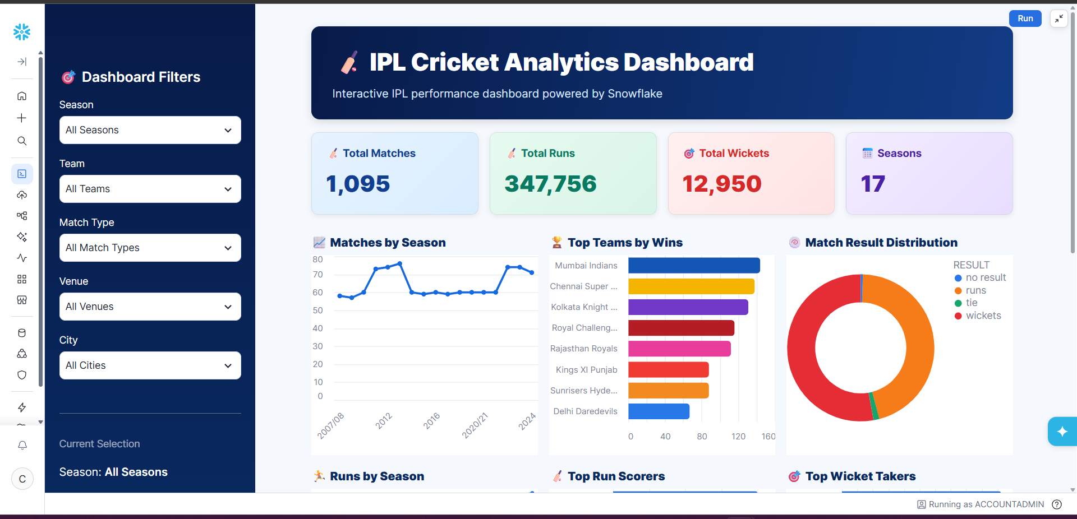
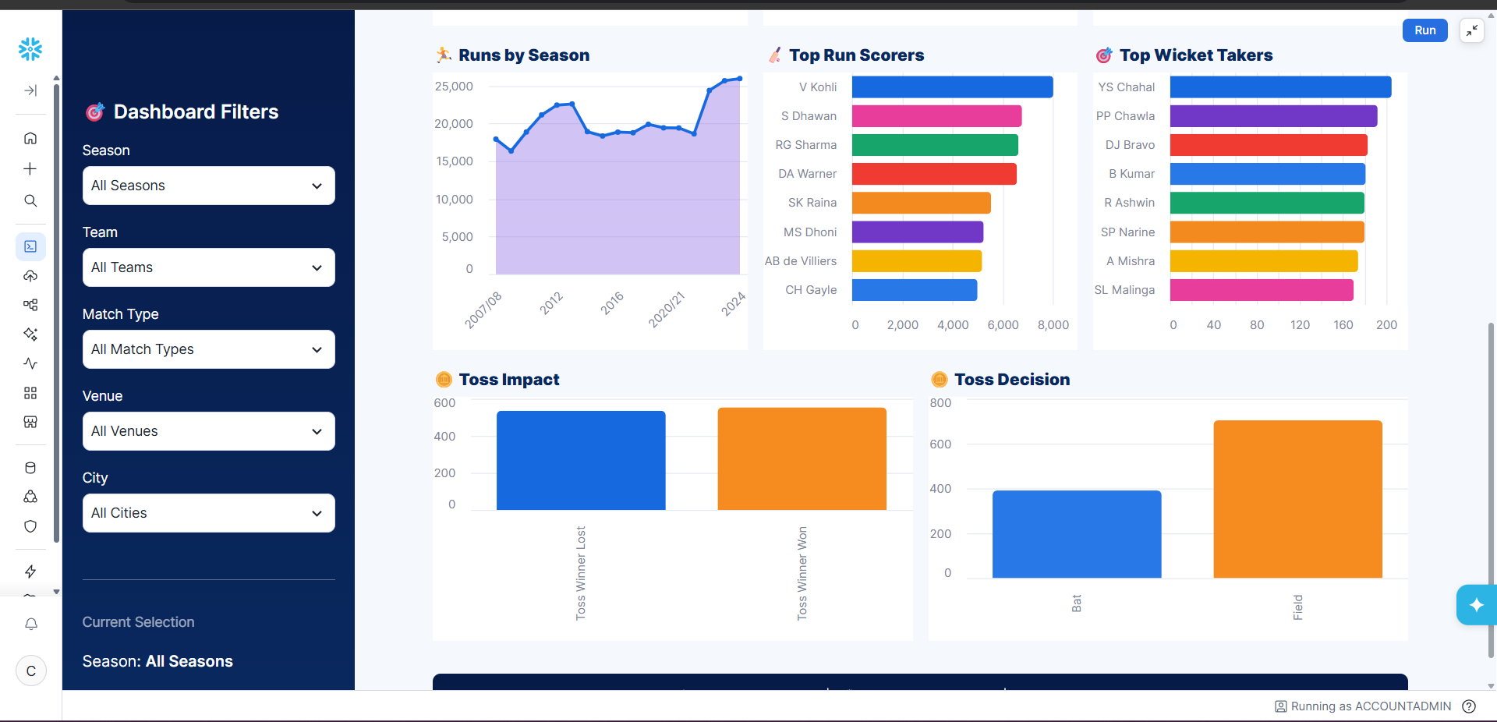
Note: Highlight the major outcomes in form of bullet points
Sample:
Here are five potential outcomes from the dashboard image provided:
- Mumbai Indians emerge as the strongest team by wins
Mumbai Indians are shown at the top of the Top Teams by Wins chart, indicating consistently strong performance across IPL seasons.
- Batting performance is dominated by a few key players
V. Kohli leads the Top Run Scorers chart, followed by players such as S. Dhawan, RG Sharma, and DA Warner. This highlights the importance of high-performing batsmen.
- Wicket-taking performance is concentrated among leading bowlers
YS Chahal ranks highest in the Top Wicket Takers chart, followed by PP Chawla and DJ Bravo, indicating that a relatively small group of bowlers has contributed significantly to wicket-taking.
- Fielding/toss decisions appear to have an impact on match outcomes
The Toss Impact and Toss Decision charts show differences between winning after winning the toss and choosing to bat vs. field. This can be used to investigate whether the toss provides a meaningful advantage.
- IPL match activity and scoring have grown over the seasons
The Matches by Season and Runs by Season charts show variation and an overall increase in IPL activity and run production across seasons, with particularly high run totals in later seasons.
Overall outcome: The dashboard suggests that IPL success is influenced by a combination of strong teams, elite batting and bowling performers, match/toss decisions, and changing scoring patterns across seasons.

Dashboard concept for the healthcare dataset
The provided project currently uses Tableau. This template adapts the same analysis as a future Snowflake-backed dashboard concept (for example, Snowflake data with Streamlit). It should not be described as deployed unless that implementation is actually completed.
Recommended layout
• Top KPI row: Total Records, Heart Disease Label Count, Diabetes Label Count, Stroke Label Count.
• Demographic section: age-group and gender comparisons using grouped bars.
• Clinical section: BMI, blood pressure, cholesterol and glucose distributions, with clear units.
• Lifestyle and symptoms: smoking, alcohol, exercise level, fatigue, chest pain and dizziness comparisons.
• Filters: age group, gender, smoking, alcohol and disease label; ensure filters apply consistently.
• Visual design: consistent Yes/No colors, concise titles, readable labels, accessible contrast and explanatory tooltips.
Major outcomes supported by the source file
• Dataset size is 5,000 rows and 16 fields.
• Positive labels: heart disease 1,499; diabetes 1,746; stroke 1,243.
• No missing cells and no exact duplicate rows were found in the supplied CSV using a basic file-level check.
• health_risk_score is 100.0 for all records, so it cannot be used to distinguish high- and low-risk records without correction.
Publication
Dashboard URL: Not available yet. Add the real URL only after deployment/publication. Do not use the example links in the original template.

